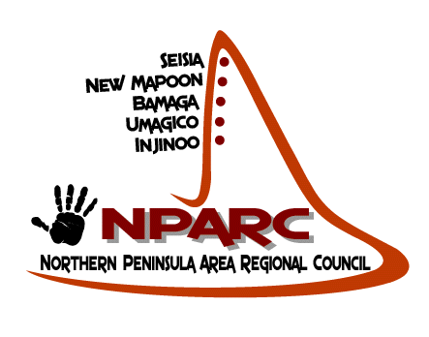
NORTHERN PENINSULA AREA REGIONAL COUNCIL
PO Box 200 Bamaga, Qld, 4876
Telephone: (07) 4090 4100
Fax: (07) 4069 3264
ABN: 27 853 926 592

RENT OR HIRE
Contract/agreement between NPARC & person/organization hiring/renting/free use or donation.
I ……………………………………………………………………………….
Do hereby understand and accept the terms {rules & regulation for the hire /use of NPARC property equipment.
I understand and accept full responsibility should any equipment or facility be returned;
- Not cleaned
- Late
- Damage
- Equipment missing or lost
And that I will be charged {tax invoiced} & expected to comply with such penalty/ies.

Date hire/use | Hire/use description | QTY | Venue/address

Return date: …………………………………………………………
Name (please print) ……………………………………………….................
Signature: ……………………………………………………………………….
Witness (NPARC staff Officer ONLY) ………………………………………………………………………………..
Date: …………………………………………………………..
NORTHERN PENINSULA AREA REGIONAL COUNCIL
PO Box 200 Bamaga, Qld, 4876
Telephone: (07) 4090 4100
Fax: (07) 4069 3264
ABN: 27 853 926 592

RENT OR HIRE
RULES AND REGULATION
- All equipment/facility is the property of the northern peninsula area regional council.

- Hire/rent of equipment/facility has to be made directly through NPARC.

- In accordance, receipted payment is required before any equipment or use of facility is taken.

- Such equipment and facility as rented/hired must be returned clean. Undamaged and same amount/number as time of hire.

- All equipment is expected to be returned as per date/s prescribed on agreement of hire.

- If no communication given to NPARC for equipment not being returned or if damaged of unaccounted for as pre hire agreement than NPARC will tax/invoice person/s responsibilities.

- The NPARC reserves the right to refuse or deny service

- Hire/booking of equipment must be made at least two {2} days prior to events & within working business hours: 8:00am to 5:00pm Monday to Thursday.
8:00am to 3:00pm Fridays
.
- In such circumstances the NPARC will at its own discretion allow equipment to be used free or at a discounted rate for community/inter-community functions. Funerals. Above rules and regulations still apply see classes 4, 5,6 and 7.

